From Grey to Green: Field-Measured Psychophysiological Responses to Urban Green Infrastructure During Everyday Mobility

Experiment Title in Ethics document - Assessing soft mobility comfort - walking and biking across distinct urban environments

Introduction
An urban mobility field experiment was conducted in the city of Brussels, Belgium from 03 July to 27 August 2025 involving 30 participants. The experiment aimed to assess the psychophysiological responses of individuals during walking and biking in green and impervious urban environments, as well as during tram journeys. Participants were equipped with non-invasive wearable sensors to measure heart rate, skin conductance, skin temperature, eye-tracking, illuminance (light colour and intensity), and air pollution. They also completed surveys on thermal comfort and psychological state before and after each exposure. The study seeks to understand how different urban environments affect commuter comfort, stress levels, and perception, with a focus on the potential benefits of green spaces in urban mobility contexts. The experiment was approved by the ethics committee of UCLouvain (reference number: 2025-05-12-01) and was conducted in accordance with the Declaration of Helsinki. Informed consent was obtained from all participants prior to their involvement in the study. Background information of participants was collected at the beginning of the experiment, and a debriefing session was held at the end to explain the study's purpose and findings. The experiment was designed to capture real-world data on how urban environments influence human well-being during everyday mobility.

Figure 1: Sensors used in the field experiment

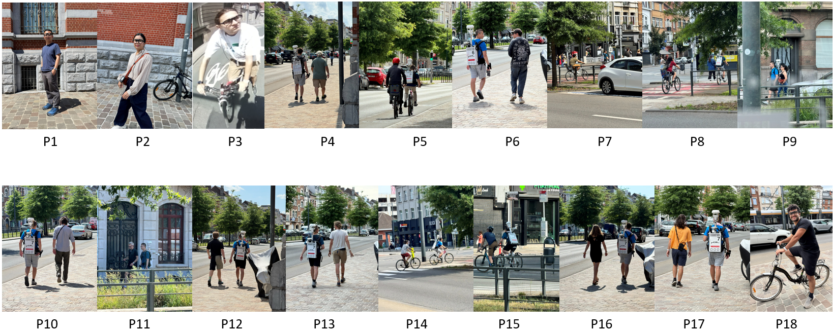
Figure 2: Participants of the field experiment

Methodology

Pre-experiment planning

Hypothesis
This study explores commuter comfort via walking, biking, and tram through different urban environments. Following hypothesis are proposed:
- Participants will show improved physiological and psychological well-being in green vs. impervious areas.
- Acclimatization takes longer after green and air-conditioned settings due to greater heat stress contrasts.
- Physiological and psychological responses will align.
- Noise & activity will amplify thermal discomfort.

1: Participants will show improved physiological and psychological well-being in green vs. impervious areas.

H (1.1-1.2): Green routes show significantly lower values in Universal Thermal Climate Index (UTCI) compared to grey (urban) routes.

Variables for 1.1-1.2: ucm__utci, empatica__temperature_celsius, ExpTime, PhaseID
  - UTCI time series groupby PhaseID
  - Skin Temperature time series groupby PhaseID

H (1.3-1.4): Activity-dependent thermal tolerance modulates green-grey differences: biking in green environments is rated more comfortable due to shade and airflow, while walking and biking in grey areas is marked uncomfortable in participant surveys.

Variables for 1.3-1.4: PhaseID, Comfort-Thermal_Numeric, Comfort-Acoustic_Numeric, Comfort-Visual_Numeric, Comfort-AQ_Numeric, Comfort-Smell_Numeric, empatica__eda_scl_usiemens, ExpTime
  - Survey Comfort vote for environmental factors (Thermal, Acoustic, Visual, Air Quality, Smell)
  - Electrodermal Activity (EDA) timeseries groupby PhaseID

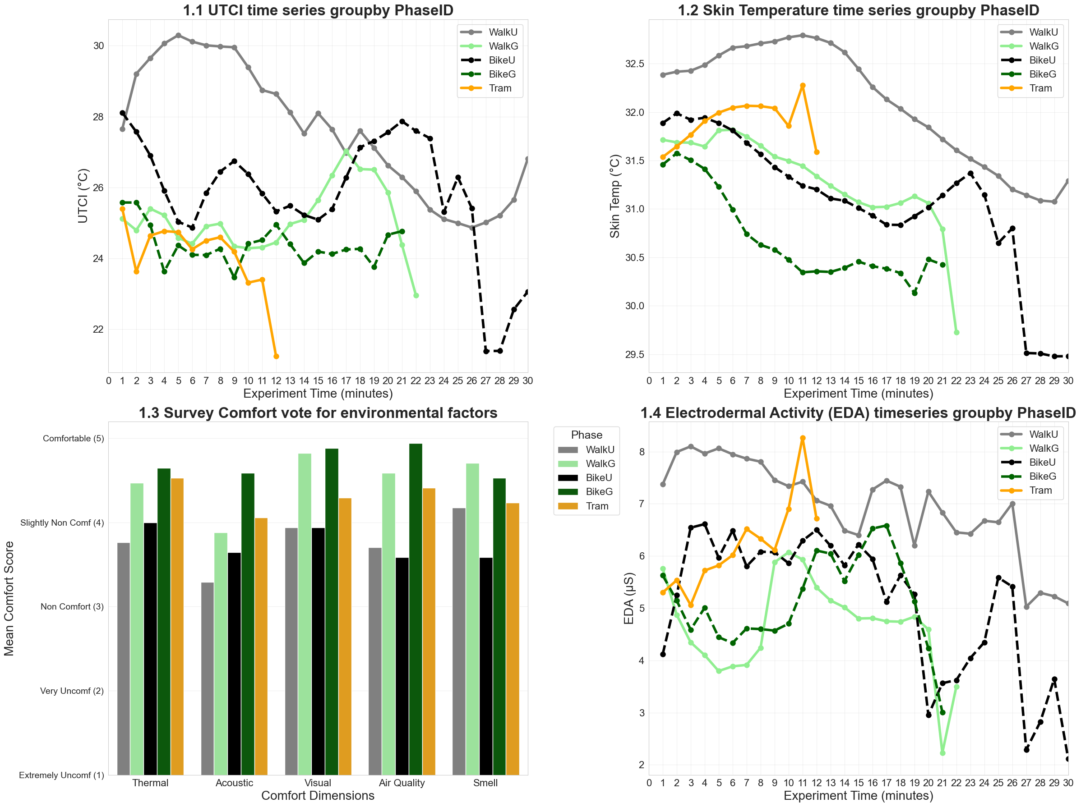

H (2.1-2.2): Green environments significantly enhance perceived restorativeness compared to grey (urban) routes. This enhancement is consistently observed across both total PRS scores and State-Trait Anxiety Inventory (STAI) (Coherence, Fascination, Being Away, and Scope).
Variables: PRS_total_100, PRS_coherence, PRS_fascination, PRS_being_away, PRS_scope, PhaseID
2.1: PRS total boxplot groupby PhaseID
2.2: PRS dimensions mean bar chart groupby PhaseID

H (2.3-2.4): Exposure to green routes modulates affective states and anxiety: activity in green spaces correlates with significantly higher positive affect and lower anxiety levels compared to grey routes, regardless of activity type.
Variables: stai_positive, stai_negative, Anxiety_100, PhaseID
2.3: Positive and Negative Affect mean bar chart groupby PhaseID
2.4: Anxiety levels boxplot groupby PhaseID

The Positive Affect and Negative Affect scores are derived from the STAI-6 (State-Trait Anxiety Inventory) questionnaire:
- Positive Affect: Calculated as the mean score of the positive-keyed items: Calm, Relaxed, and Content.
- Negative Affect: Calculated as the mean score of the negative-keyed items: Tense, Upset, and Worried.
Both are measured on a scale of 1 to 4, where a higher score indicates a stronger presence of that affect.
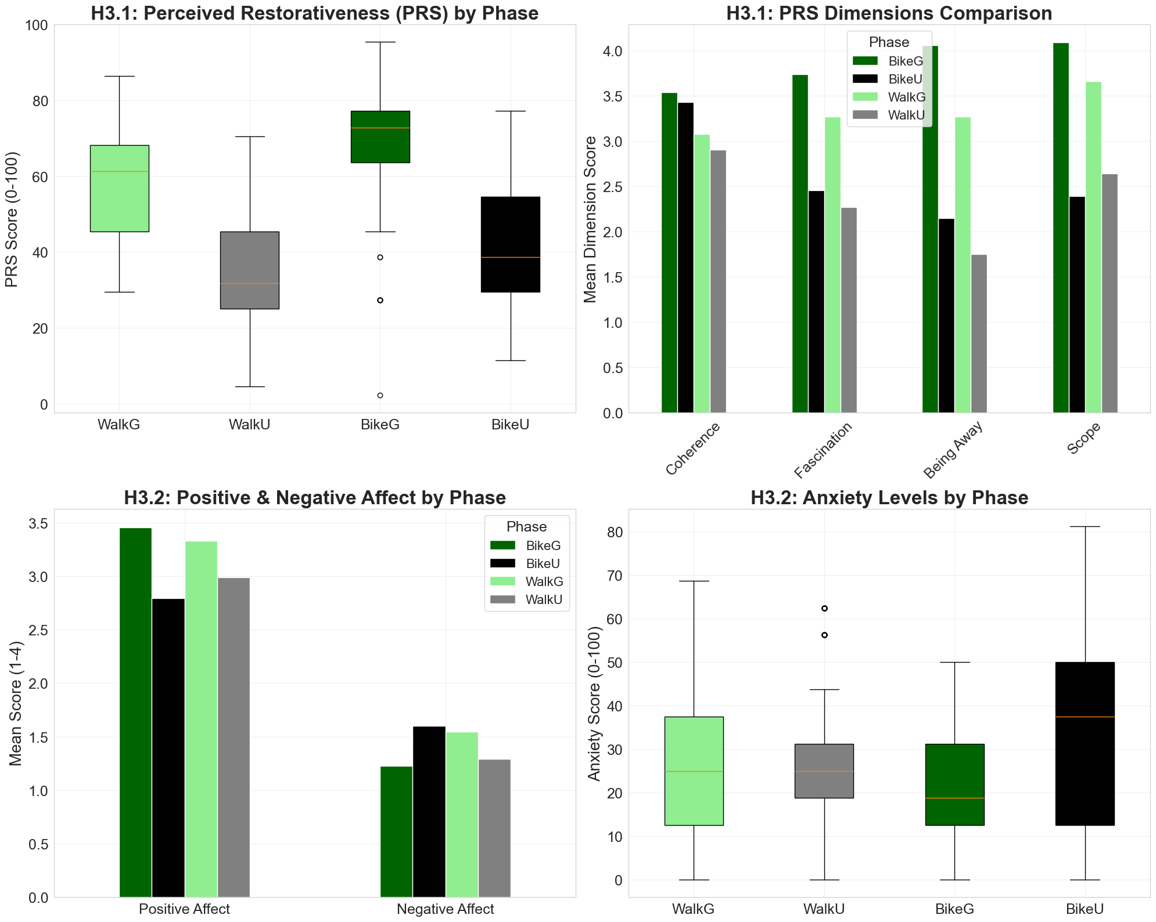

--------------

Clearness Index
Clearness index $k_{t}(t)=G_{H}(t)/G_{0}(t)$, where $G_{H}$is the measured global horizontal irradiance (ucm__sun_gh) and $G_{0}(t)=G_{sc} E_{0}(n) sin⁡α(t)$. $G_{sc}=1367 {\text{W\backslash m}}^{2}$ is the solar constant and $E_{0}(n)=1+0.033cos⁡(2πn/365)$ where n is day of year (df['day'] = df['timestamp'].dt.dayofyear)
Extraterrestrial irradiance as $G_{0}(t)=G_{sc} E_{0}(n) sin⁡α(t)$, where $G_{sc}=1367 {\text{W\backslash m}}^{2}$ is the solar constant and $E_{0}(n)=1+0.033cos⁡(2πn/365)$ corrects for Earth–Sun distance (day-of-year $n$).
Clearness index was then calculated as $k_{t}(t)=G_{H}(t)/G_{0}(t)$, where $G_{H}$is the measured global horizontal irradiance (ucm__sun_gh). Values were computed only for sun altitudes $> 5^{∘}$; lower angles were treated as invalid. (Equation and formulation after Duffie & Beckman, Solar Engineering of Thermal Processes, Eq. 1.10.1–1.10.2.)
$$G_{0}(t)$$ | Extraterrestrial solar radiation on horizontal surface | G0
$$G_{sc}$$ | Solar constant (~1367 W/m²)
  Gsc = 1367
$$E_{0}(n)$$ | Correction for Earth-Sun distance | E0
$$n$$ | Day of the year (1–365)
  df['day']
$$α$$ | Sun altitude angle
  df['ucm__sun_alt']
t | Time | df[‘Time’]

Sample size calculation for the experiment
This study recruited 30 participants. This sample size of 30 was obtained based on the following statistical calculations (with the assumption that medium effect size is achieved):
- Paired t-tests are used to detect mean differences between two conditions measured within the same participant. In this experiment, they are applied to compare psychological and physiological outcomes between green and impervious urban environments (Hypothesis 1), as well as between biking and walking. Based on a medium effect size (d = 0.50), this results in a sample size requirement of 27 participants.
- Repeated measures ANOVA can detect differences across several repeated conditions within participants. In this experiment, each participant is observed under five mobility–environment combinations (walking, biking, and tram, across green and impervious settings), allowing assessment of interaction effects such as acclimatization and thermal comfort dynamics (Hypothesis 2 & 4). Considering a medium effect size (f = 0.25), a required sample size of 17 participants was obtained.
- Wilcoxon Signed-Rank Test is applied to assess the association between subjective thermal comfort responses and physiological sensor data, such as heart rate, EDA, or skin temperature (Hypothesis 3). With a medium effect size (d = 0.50), the sample size requirement is 28 participants.
Based on the more conservative requirement of 28 participants and accounting for a 5% potential attrition rate, the study will recruit 30 participants in total. This within-subject design allows each participant to experience all conditions, minimizing individual variability and fatigue, while enabling the collection of continuous real-world data and ensuring sufficient statistical power to test the primary hypotheses. Hypothesis 5, which examines the potential amplifying effect of urban noise and activity on perceived thermal discomfort, is considered exploratory and was not included in priori power calculations. It will be examined descriptively using environmental data (e.g., sound pressure levels), but no formal statistical testing is planned.

Three a priori power analyses align with the primary within-subject design:
- Paired t-test for the diurnal contrast (Green vs Impervious).
- Repeated-Measures ANOVA across mobility modes (walk, bike, tram), each performed in afternoon.
- Wilcoxon Signed-Rank Test for comparing subjective and physiological responses (e.g. reported vs. measured comfort).
- Significance level (α): 0.1
- Target power (1 – β): 0.80
- Within-subject conditions: 5 (walk-green, bike-green, tram, walk-urban, bike-urban)
- Effect-size grid (expecting medium to large effect size):
  - Paired t: Cohen’s d = 0.50 (Medium), 0.80 (Large)
- Cohen’s f notation (medium = 0.25, large = 0.40)
- Dropout cushion: +5% recruitment
Table 3: Sample Size Analysis Results
Analysis Method | Effect Size Category | Effect Size Value | Required N | Notes
Paired t-test | Medium | d = 0.50 | 27 participants | Can detect medium differences between two conditions measured on the same participants (Hypothesis 1: green vs. impervious).
Paired t-test | Large | d = 0.80 | 12 participants | Can detect large differences between two conditions measured on the same participants (Hypothesis 1: green vs. impervious).
Repeated-Measures ANOVA | Medium | f = 0.25 | 17 participants | Can detect medium differences across several repeated conditions per participant (Hypothesis 2 & 4: interaction of mobility mode and environment type — walking, biking × green, impervious).
Repeated-Measures ANOVA | Large | f = 0.4 | 8 participants | Can detect large differences across several repeated conditions per participant (Hypothesis 2 & 4: interaction of mobility mode and environment type — walking, biking × green, impervious).
Wilcoxon Signed-Rank Test | Medium | d = 0.50 | 28 participants | For detecting medium changes between two related non-normally distributed measures (Hypothesis 3: subjective vs. physiological response).
Wilcoxon Signed-Rank Test | Large | d = 0.80 | 12 participants | For detecting large changes between two related non-normally distributed measures (Hypothesis 3: subjective vs. physiological response).

Route planning

Post-experiment data processing

Data compilation

Hypothesis testing

- Primary Analysis
  - Using all the data with a mixed-effects model that accounts for repeated measures and includes order/sequence as covariates.
- Sensitivity Analysis
  - A restricted comparison that only uses participants who did the same full ordered sequence (clean but smaller N) and also run the within-condition order contrasts (e.g., Bike→Walk vs Walk→Bike within green).

Effect size - Annova

Interactive Dashboard

Population categorization
Using the background information form, participants were categorizing based on their physical activity levels.
Table 1: Participant Characteristics - Height and Weight
BMI Range | (Weight / height squared) | Participants
Underweight | 18.5 to 24.9 | 1
Normal | 25 to 29.9 | 12
Overweight | 30 to 34.9 | 4
Obesity | 35 to 39.9 | 1
Obesity | 40 and above | 0

Table 2: Participants Physical Activity Levels
Active- How much do you walk daily | Participants
< 15 minutes | 1
15 to 30 minutes | 8
30 minutes to 1 hour | 7
1 to 2 hour | 2

Theoretical framework (around 5 lines)
An urban mobility field experiment was conducted in the city of Brussels, Belgium from 03 July to 27 August 2025 involving
Brussel Capital Region particular in the neighborhood of
The research was titled “Assessing urban mobility comfort - commuting across distinct urban environments”.
Multi-sensory discomfort arises from complex environmental exposures, yet most studies focus on stationary subjects^{1, 2}. This overlooks the dynamic interaction between environment, perception, and stress in mobile users^{3, 4, 5, 6}. Thermal acclimatization—how quickly the body adjusts between shaded parks, exposed urban streets, or air-conditioned transport—takes up to 25 minutes indoors⁷, but remains unclear outdoors.
This study explores commuter comfort via walking, biking, and tram through different urban environments. Hypothesis: 1) Participants will show improved physiological and psychological well-being in green vs. impervious areas. 2) Acclimatization takes longer after green and air-conditioned settings due to greater heat stress contrasts. 3) Physiological and psychological responses will align. 4) Noise & activity will amplify thermal discomfort.

      - Population: This study will recruit 30 participants (aged 18–40) with equal gender representation (50% male, 50% female), determined via power analysis (in Appendix A).
      - Experiment: Participants will engage in three phases: 1) a green environment, 2) an impervious urban environment, and 3) a tram journey. In the green and impervious phases, both walking and biking will be performed for 30 minutes each; during the tram phase, participants will remain seated for 30 minutes. In each phase there will be a 10-minute break for participants to rest, drinking water will be provided. Duration of experiment 1:30–5:30 pm in Etterbeek, with tram used to transition between phase 1 & 2.
      - Participants will wear four non-invasive sensing devices: 1) Empatica Embrace Plus smartwatch (measuring EDA, PPG, wrist skin temperature), 2) Pupil Labs Neon smart glasses (eye-tracking), 3) LYS Button (measuring illuminance) and 4) Atmotube PRO measuring air pollution. Sensors 3 & 4 will be worn on participant’s shirt or jacket.
      - Environmental conditions will be measured by a researcher carrying a uCM backpack system (thermal stress, temperature, humidity, radiation, wind, sound, GPS, comfort indices)⁸. If any clarification is required for environmental sensors, head of ethics commission of LAB – Prof. Sergio Altomonte has proposed to get in touch with him.
Participants will complete shortened psychological and comfort-related questionnaires (STAI-6¹⁰, PRS-11^{9,11}, CSV, TSV¹³) & two custom questions (Environment) before & after each exposure. Breaks are scheduled between sessions for recovery, survey completion, and sensor checks. Participation is voluntary, with a right to pause or withdraw at any time.

Ucm Image processing
Used Kannala-Brandt Equidistant model https://ieeexplore.ieee.org/document/1642666 for processing fisheye images.

--
As mentioned in Section 1.4, participants will be monitored only using non-invasive and non-intrusive wearable sensors. Empatica wristband is a smartwatch measuring heart rate, skin temperature and electrodermal activity PupilLabs eye-trackers measure, Visual fixation patterns, Saccade movements (velocity, amplitude, direction), Pupil dilation response to environmental stimuli and track Areas of Interest (AOI). Additionally, participants will also wear LYS Button for measuring illuminance due to sunlight.

B) Survey during the experimental campaign
These surveys include participants’ thermal and psychological perceptual responses to urban environments during urban commuting. The survey incorporates elements from validated and shortened standardized questionnaires covering both thermal and psychological dimensions. These include the Comfort Sensation Vote (CSV) and Thermal Sensation Vote (TSV) for thermal perception (Xue et al., 2020), the 6-item State-Trait Anxiety Inventory (STAI-6) for psychological stress (Marteau and Bekker, 1992; Spielberger, 1983), and the 11-item Perceived Restorativeness Scale (PRS-11) for environmental restoration (Hartig et al., 1997; Pasini et al., 2014). Additionally, custom-made questions on comfort and environmental pleasantness (Environmental Stressor and Greenness) have also been included (see complete survey in table 2). The survey will require approximately 4 minutes of time to fill in.

As described in figure 1 the experiment will begin at 1:30 pm and will end at 5:30 pm. Upon arrival participants will be invited to sit in an air-conditioned room for the signing of the consent form, the installation of the physiological sensors, and the filling in of the ‘participant background information’ form and to complete the survey. Then the participants will be asked to either bike or walk along a predefined path for 30 minutes. Once this is completed, the sensors will be checked, and the participants will be asked to fill in the survey. Once this is completed another block of 30 minutes of either biking or walking will follow. Once this is completed, once again the sensors will be checked, and the participant will be asked to fill in the survey. These two initial blocks of 30 minutes of biking and walking will take place in either green or impervious urban environments – choice that will be randomized as it will be the order on which the participant will walk or bike first. This initial block of data collection will be followed by a tram route with a total duration of ~30min where the participant will be sitting in an air-conditioned environment. This will bring the participant back to the initial location to start block two, which will be organized as block one. Before the following 30 minutes of biking or walking, the participant is asked to fill in the survey once more. Block two will unfold as per block one after which the participant will have completed the experiment. Along with the experimental campaign, refreshments will be provided.
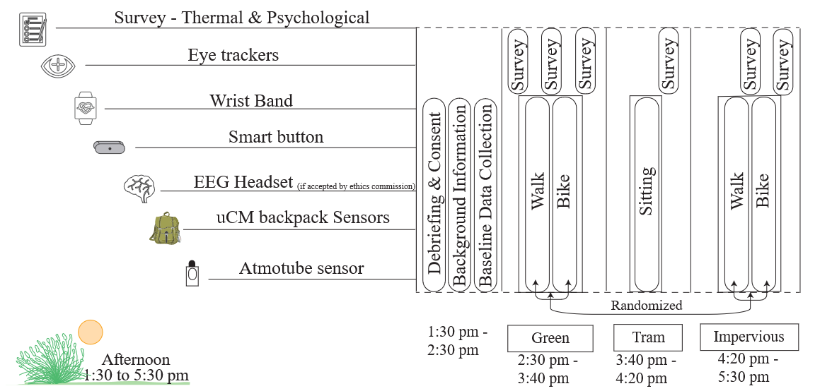
Figure 1. Experimental Campaign Timeline

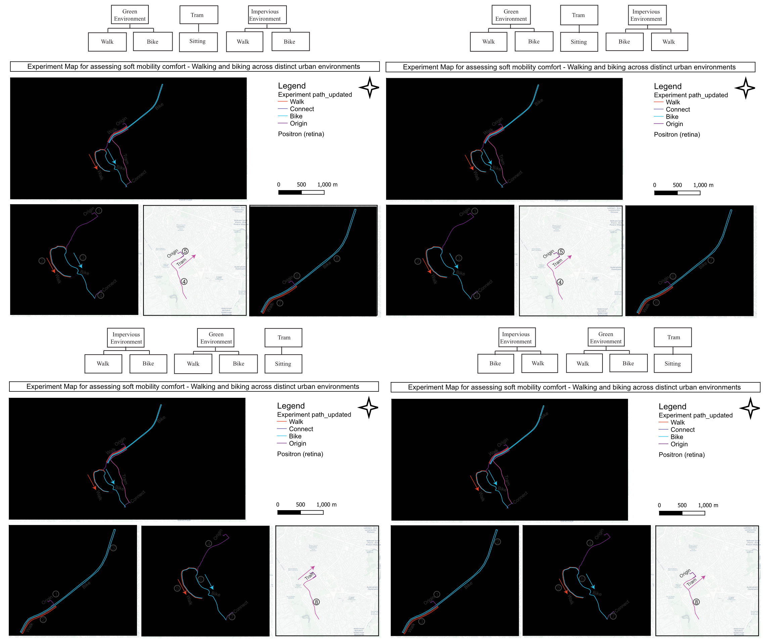

Annex

Annex 1: Participant Information Sheet
In this study, you will be asked to participate in a series of assessments during commuting routes in the Brussels Capital Region (BCR). The experiment will take place from 1:30 to 5:30 pm. In this time, you will alternate between walking and biking along urban bike and pedestrian routes. You will also be asked to take the tram. Researchers from UCLouvain will be accompanying you along these urban routes. You will wear non-invasive and non-intrusive wearable sensors to measure heart-rate variability, skin conductance, skin temperature, together with EEG (if it is accepted by ethics commission) and eye-tracking glasses and illuminance due to sunlight. You will also complete brief surveys about your emotional state and your perceptions of the urban environment. These surveys will be administered at the beginning & end of each phase before or after biking/walking, to track changes in your physiological responses and psychological state as you move through different urban settings.
Your participation is entirely voluntary. All information collected will be handled in accordance with GDPR and the Belgian Law of 30 July 2018 on the protection of individuals with regard to the processing of personal data. By signing this consent form, you agree to take part in this study and consent to anonymous statistical analyses of the data you provide. You may withdraw any or all of your data from the study at any time without consequence. All data will be stored securely UCLouvain regulations; see https://www.uclouvain.be/en/privacy for details.
Informed Consent Form
- I have read the Participant Information Sheet, and the nature and purpose of the study have been explained to me.
- I understand the study’s purpose and what my participation entails, and I agree to take part.
- I understand that I may withdraw from the study at any time, and this will not affect my status now or in the future.
- I understand that, while anonymized data gathered during the study may be published, I will not be identified in any form, and my personal information will remain strictly confidential.
- I understand that data from this study will be stored in a secure location in accordance with UCLouvain regulations, and only the investigator and supervisor will have access.
- I understand I may contact the investigator or supervisor at any time if I require further information about the study.
Please indicate your consent by signing your name and date below:

__________________________________________________________________________
- Investigator: Pranav Pandya, pranav.pandya@uclouvain.be
- Promoter: Maider Llaguno-Munitxa, maider.llaguno@uclouvain.be | Co-promoter: Martin Edwards, martin.edwards@uclouvain.be

Annex 2: Background Information form
Background information forms will be filled at the beginning of the experiment (see table 1). These questions are designed to collect basic demographic, residential, and behavioral information that may help contextualize each participant’s responses during the experiment. The form also captures participants’ physical characteristics relevant to sensor use (e.g., vision correction and handedness), as well as their mobility habits and familiarity with the study area. This information will not be used to exclude participants but to aid in the interpretation of collected psychophysiological data.

Table 1: Participant Background Information
Category | Questions | Response Type
Identity | - What is your name? | Text field
Demographics | - What is your age? | Text field
Demographics | - What is your gender? | Multiple choice: Male/ Female/ Prefer not to say
Demographics | - What is your nationality or country of origin? | Text field
Residence | - Where do you live in Brussels? | Text field
Residence | - How long have you been living in Brussels? | Text field
Physical Characteristics | - What is your laterality? (Are you left or right-handed?) | Binary choice: Left / Right
Physical Characteristics | - What is your current body weight? In Kg. | Text field
Physical Characteristics | - What is your height? In cm. | Text field
Physical Characteristics | - What are you currently wearing? Please describe your outfit as precisely as possible with colour (e.g., short-sleeved shirt, jeans, sandals, light jacket, etc.). | Text field
Physical Characteristics | - What do you normally use for vision correction? | Multiple choice: Normal vision/ Wear glasses/ Wear contact lens / Uncorrected vision impairment/ Prefer not to say
Familiarity | - How well do you know the streets and surroundings where the experiment is in Brussels? | Linear scale 1–10: Not at all familiar (1) / Extremely familiar (10)
Living Environment | - What is your type of residence? | Binary choice: City / Suburban environment
Household | - Do you have children? | Multiple choice: Yes / No
Mobility | - How do you commute to work? | Multiple choice: Walk/ Bike/ Train/ Metro/ Tram
Physical Activity | - Is there any sport or physical activity you practice regularly? Name it. Else write no. | Text field
Physical Activity | - How frequently do you bike? | Multiple choice: Daily/ Few times per week/ Few times per month/ Rarely/ Never
Physical Activity | - On average how much do you walk every day? | Multiple choice: <15 min/ 15 to 30 min/ 30 min to 1 hour/ 1 to 2 hours/ > 2 hours

Annex 3: Experimental Campaign Questionnaires
Item | Question | Response Format | Source Framework
1 | How comfortable do you feel right now? | Very uncomfortable / Uncomfortable / Slightly uncomfortable / Neutral / Slightly comfortable / Comfortable / Very comfortable | Comfort Sensation Vote
2 | Please describe your thermal sensation | Cold / Cool / Slightly cool / Neutral / Slightly warm / Warm / Hot | Thermal Sensation Vote
3 | Which environmental factor is most affecting you right now? | □ Temperature □ Lighting □ Noise  □ Air Quality □ Crowding | Environmental Stressor
4 | I feel calm | Not at all / A little / Moderately / Quite a lot / Extremely | STAI
5 | I feel tense | Not at all / A little / Moderately / Quite a lot / Extremely | STAI
6 | I feel upset | Not at all / A little / Moderately / Quite a lot / Extremely | STAI
7 | I feel relaxed | Not at all / A little / Moderately / Quite a lot / Extremely | STAI
8 | I feel content | Not at all / A little / Moderately / Quite a lot / Extremely | STAI
9 | I feel worried | Not at all / A little / Moderately / Quite a lot / Extremely | STAI
10 | Places like that are fascinating | Not at all / A little / Moderately / Quite a lot / Extremely | PRS
11 | In places like this my attention is drawn to many interesting things | Not at all / A little / Moderately / Quite a lot / Extremely | PRS
12 | In places like this it is hard to be bored | Not at all / A little / Moderately / Quite a lot / Extremely | PRS
13 | Places like that are a refuge from nuisances | Not at all / A little / Moderately / Quite a lot / Extremely | PRS
14 | To get away from things that usually demand my attention I like to go to places like this | Not at all / A little / Moderately / Quite a lot / Extremely | PRS
15 | To stop thinking about the things that I must get done I like to go to places like this | Not at all / A little / Moderately / Quite a lot / Extremely | PRS
16 | There is a clear order in the physical arrangement of places like this | Not at all / A little / Moderately / Quite a lot / Extremely | PRS
17 | In places like this it is easy to see how things are organised | Not at all / A little / Moderately / Quite a lot / Extremely | PRS
18 | In places like this everything seems to have its proper place | Not at all / A little / Moderately / Quite a lot / Extremely | PRS
19 | That place is large enough to allow exploration in many directions | Not at all / A little / Moderately / Quite a lot / Extremely | PRS
20 | In places like that there are few boundaries to limit my possibility for moving about | Not at all / A little / Moderately / Quite a lot / Extremely | PRS
21 | How pleasant do you feel in this place? | Not at all / A little / Moderately / Quite a lot / Extremely | Greenness
STAI (State-Trait Anxiety Inventory)
- Spielberger, C. D., Gorsuch, R. L., Lushene, R., Vagg, P. R., & Jacobs, G. A. (1983). Manual for the State-Trait Anxiety Inventory. Palo Alto, CA: Consulting Psychologists Press.
- Julian, L. J. (2011). Measures of anxiety: State-Trait Anxiety Inventory (STAI), Beck Anxiety Inventory (BAI), and Hospital Anxiety and Depression Scale-Anxiety (HADS-A). Arthritis Care & Research, 63(S11), S467-S472.
PRS (Perceived Restorativeness Scale)
- Hartig, T., Korpela, K., Evans, G. W., & Gärling, T. (1997). A measure of restorative quality in environments. Scandinavian Housing and Planning Research, 14(4), 175-194.
- Pasini, M., Berto, R., Brondino, M., Hall, R., & Ortner, C. (2014). How to measure the restorative quality of environments: The PRS-11. Procedia-Social and Behavioral Sciences, 159, 293-297.
- Meredith, G. R., Rakow, D. A., Eldermire, E. R. B., Madsen, C. G., Shelley, S. P., & Sachs, N. A. (2020). Minimum Time Dose in Nature to Positively Impact the Mental Health of College-Aged Students, and How to Measure It: A Scoping Review. Frontiers in Psychology, 10, 2942. https://doi.org/10.3389/fpsyg.2019.02942

CSV (Comfort Sensation Vote) & TSV (Thermal Sensation Vote)
- Xue, J., Hu, X., Sani, S. N., Wu, Y., Li, X., Chai, L., & Lai, D. (2020). Outdoor Thermal Comfort at a University Campus: Studies from Personal and Long-Term Thermal History Perspectives. Sustainability, 12(21), Article 21. https://doi.org/10.3390/su12219284
- Gagge, A., Stolwijk, J. A., & Hardy, J. D. (1967). Comfort and thermal sensations and associated physiological responses at various ambient temperatures. Environmental Research, 1(1), 1–20. https://doi.org/10.1016/0013-9351(67)90002-3

Annex 4: Recruitment Posters

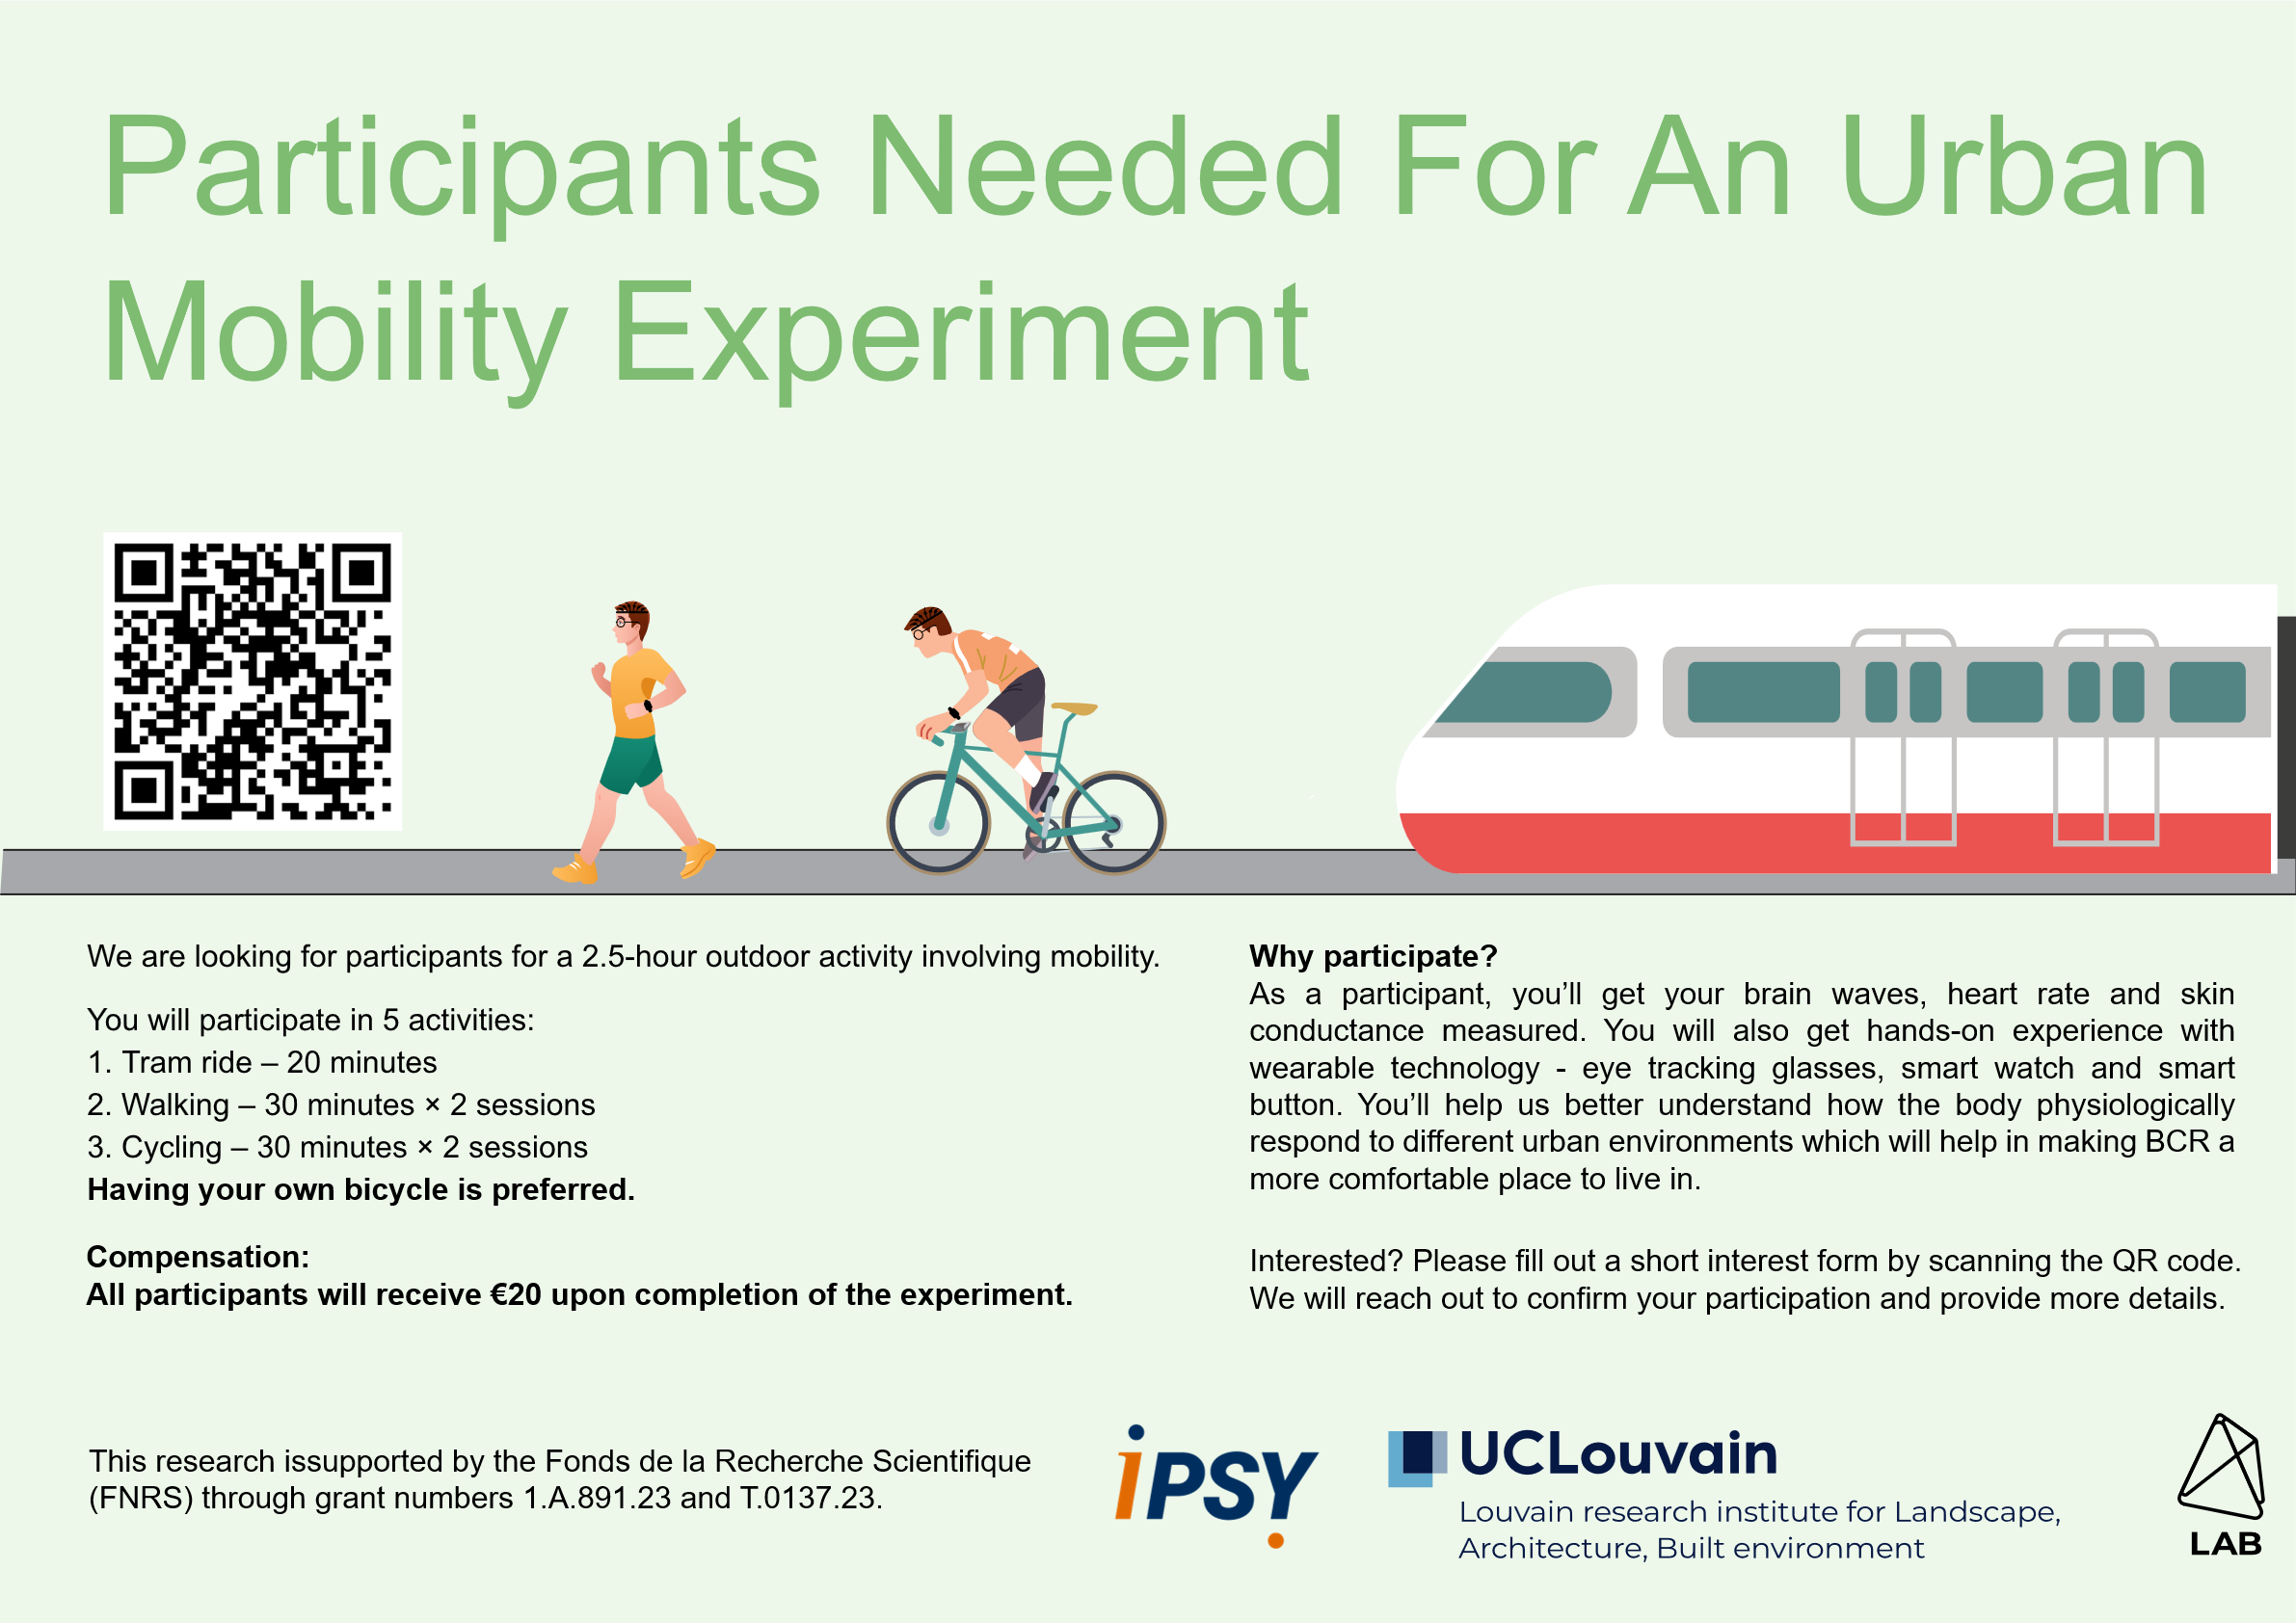
Figure 2: Poster – Participation Call

Call to be shared for the experimental campaign:
We are recruiting 30 individuals aged 18-40 for a research study examining comfort, stress, and perception during walking and biking. The study aims to explore whether individuals feel greater discomfort in impervious areas, whether green spaces reduce stress and enhance emotional well-being, and how different modes of movement (such as biking versus walking) may vary in perceived effort or stress.

Participation involves performing walking, biking and riding trams in Brussels in green and urban spaces. You'll wear non-invasive and non-intrusive sensors measuring heart rate, skin conductance, and temperature, along with eye-tracking glasses and button for measuring illuminance due to sunlight, while completing brief surveys about your emotional state. All instruments are safe, your data will remain confidential, and you may pause or withdraw at any time. If interested, please contact us here: pranav.pandya@uclouvain.be.

Annex 5: Debriefing Participants

Thank you for taking part in the experiment “Assessing urban mobility comfort - commuting across distinct urban environments.”

What We’re Hoping to Learn:
- You may have felt more discomfort in areas without greenery, especially when it was hot.
- Green spaces may help reduce stress and improve how people feel.
- Urban noise may have felt more discomforting with in thermal stress.
- We’re also checking if what people report feeling matches their body’s signals (like heart rate or sweating).

All the information you provided will remain confidential and will only be used for research purposes. You maintain the right to withdraw your data within 30 days by contacting us. If you have any questions about this research, please reach us out at pranav.pandya@uclouvain.be

References:
Lee, J., Lee, J., Kim, T. W., & Koo, C. (2022). EEG-Based Circumplex Model of Affect for Identifying Interindividual Differences in Thermal Comfort. Journal of Management in Engineering, 38. https://doi.org/10.1061/(ASCE)ME.1943-5479.0001061

Ma, X., Song, L., Hong, B., Li, Y., & Li, Y. (2023). Relationships between EEG and thermal comfort of elderly adults in outdoor open spaces. Building and Environment, 235, 110212. https://doi.org/10.1016/j.buildenv.2023.110212

Maruyama, Y., Nakamura, R., Tsuji, S., Xuan, Y., Mizutani, K., Okaze, T., & Yoshimura, N. (2024). Classification of pleasantness of wind by electroencephalography. PLOS ONE, 19(2), e0299036. https://doi.org/10.1371/journal.pone.0299036

Appendix B
Representation of Sensors which will be worn by participants

Participants will wear

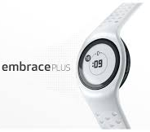 | 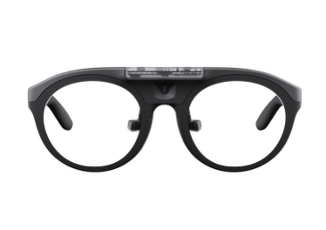 | 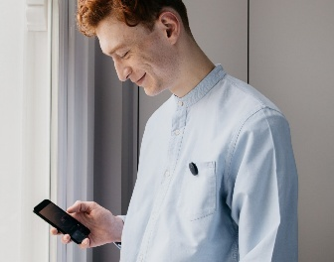
Empatica Embrace Plus (Smart Watch) | Pupil Labs Neon smart glasses (eye-tracking) | LYS Button (measuring illuminance)
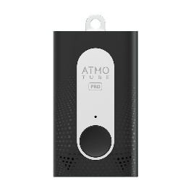
Atmotube PRO measuring air pollution

Appendix C
Time period selection for experiment

SOLWEIG (Solar and Long Wave Environmental Irradiance Geometry) model was used to simulate mean radiant temperature (Tₘᵣₜ) for 2022 to 2024. Human thermal comfort indices - Physiologically Equivalent Temperature (PET) and Universal Thermal Climate Index (UTCI) were generated. These were calculated using the Pythermalcomfort library with inputs including Tmrt, wind speed, relative humidity, and air temperature.

On hourly plot, Tₘᵣₜ peaked at roughly 53.9 °C around midday (when solar radiation is highest), but PET and UTCI—because they also respond to the slower‐warming air mass and the cooling effects of wind—peaked later at 15 & 16 hour.

PET and UTCI values are elevated between 2:00 pm and 5:00 pm. To capture this peak period while allowing time for consent and preparation, participants are asked to arrive at 1:30 pm. Therefore, the experimental window was set from 1:30 pm to 5:30 pm.

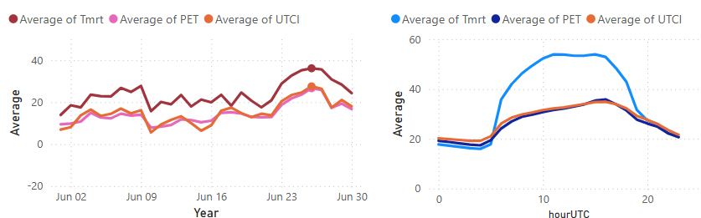
Figure 3: Plot of Tmrt and thermal comfort indices – PET & UTCI for impervious environment.

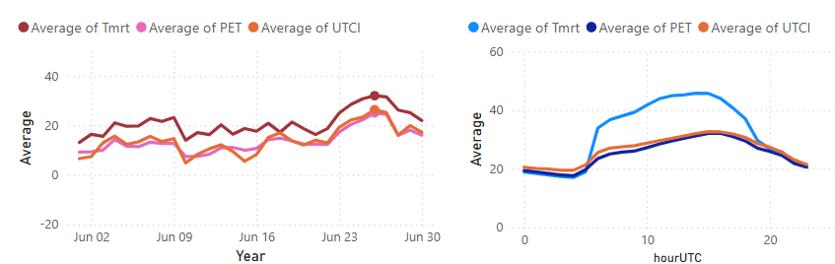
Figure 4: Plot of Tmrt and thermal comfort indices – PET & UTCI for green environment.

Appendix D
Route Safety Planning of Experiment
- The participants will always be accompanied by a PhD researcher.
- The experiment will be done in dedicated bike paths which ensures that safe distance from participants will be maintained and there will be no risks such as overtaking or sudden stoppage.
- The dedicated bike paths have separate signals for bike riders which prevent the risk of accidents.
- In the planning of experiment there is a 10 minute of break after every two blocks (1 break in green and 1 break in urban areas) during which they must walk and ride a bike. This break time is always available to participants upon request.

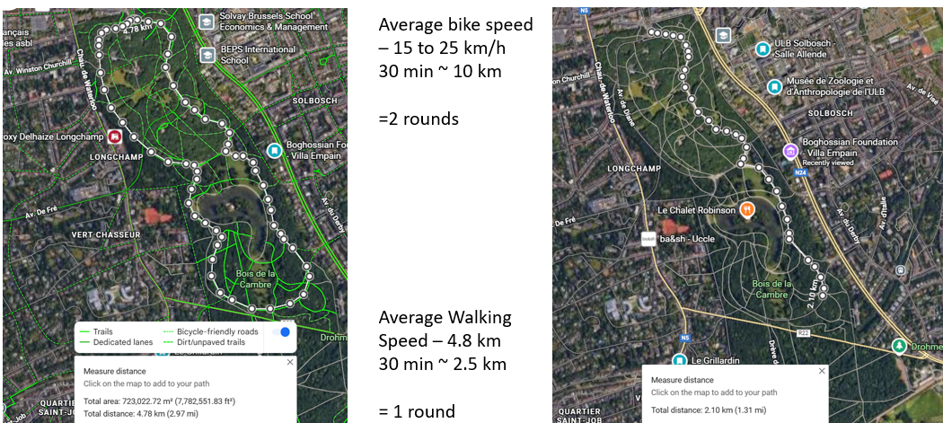
Figure 5: Green Environment Bike and walking path

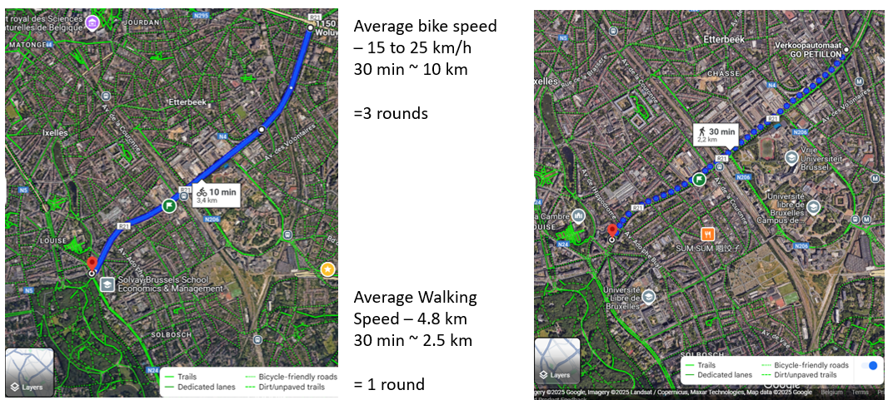
Figure 6: Impervious environment bike and walking path

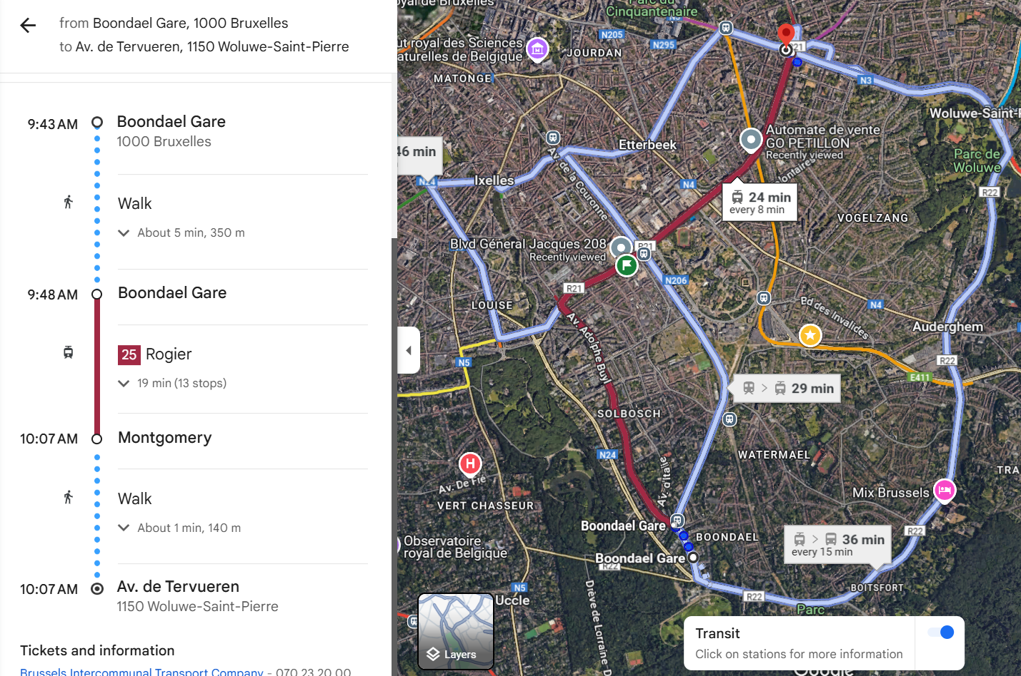
Figure 7: Tram journey

References
- Nikolopoulou, M., Baker, N., & Steemers, K. (2001). Thermal comfort in outdoor urban spaces: Understanding the human parameter. Solar Energy, 70(3), 227–235. https://doi.org/10.1016/S0038-092X(00)00093-1
- Traunmueller, M., Marshall, P., Capra, L., 2016. “...when you’re a Stranger”: Evaluating Safety Perceptions of (un)familiar Urban Places, in: Proceedings of the Second International Conference on IoT in Urban Space, Urb-IoT ’16. Association for Computing Machinery, New York, NY, USA, pp. 71–77. https://doi.org/10.1145/2962735.2962761
- Zheng, H., Luo, M., Wang, Y., Wei, Y., 2024. Multi-Sensory Interaction and Spatial Perception in Urban Microgreen Spaces: A Focus on Vision, Auditory, and Olfaction. Sustainability 16, 8809. https://doi.org/10.3390/su16208809
- Fleming, W., Rizowy, B. and Shwartz, A. (2024) 'The nature gaze: Eye-tracking experiment reveals well-being benefits derived from directing visual attention towards elements of nature', People and Nature, accepted 21 March 2024. doi:10.1002/pan3.10648
- Mavros, P., Wälti, M. J., Nazemi, M., Ong, C. H., & Hölscher, C. (2022). A mobile EEG study on the psychophysiological effects of walking and crowding in indoor and outdoor urban environments. Scientific Reports, 12(1). https://doi.org/10.1038/s41598-022-20649-y
- Lin, Y., Jin, Y., & Jin, H. (2022). Effects of different exercise types on outdoor thermal comfort in a severe cold city. Journal of Thermal Biology, 109. https://doi.org/10.1016/j.jtherbio.2022.103330
- Gnecco, V.M., Chiucchiù, A., Mansi, S.A., Pigliautile, I., Cosoli, G., Arnesano, M., Pisello, A.L., 2025. Exploring acclimation time in test-room environments via physiological indicators: Evolving human-centric personalized comfort measurement procedures. Build. Environ. 277, 112924. https://doi.org/10.1016/j.buildenv.2025.112924
- Gallinelli, P., Camponovo, R., Guillot, V., 2017. CityFeel - micro climate monitoring for climate mitigation and urban design. Energy Procedia, CISBAT 2017 International ConferenceFuture Buildings & Districts – Energy Efficiency from Nano to Urban Scale 122, 391–396. https://doi.org/10.1016/j.egypro.2017.07.427
- Hartig, T., Korpela, K., Evans, G.W., Gärling, T., 1997. A measure of restorative quality in environments. Scand. Hous. Plan. Res. 14, 175–194.
- Marteau, T.M., Bekker, H., 1992. The development of a six-item short-form of the state scale of the Spielberger State-Trait Anxiety Inventory (STAI). Br. J. Clin. Psychol. 31, 301–306. https://doi.org/10.1111/j.2044-8260.1992.tb00997.x
- Pasini, M., Berto, R., Brondino, M., Hall, R., Ortner, C., 2014. How to Measure the Restorative Quality of Environments: The PRS-11. Procedia - Soc. Behav. Sci., 5th World Conference on Psychology, Counseling and Guidance, WCPCG-2014, 1-3 May 2014, Dubrovnik, Croatia 159, 293–297. https://doi.org/10.1016/j.sbspro.2014.12.375
- Spielberger, C.D., 1983. State-trait anxiety inventory for adults.
- Xue, J., Hu, X., Sani, S.N., Wu, Y., Li, X., Chai, L., Lai, D., 2020. Outdoor Thermal Comfort at a University Campus: Studies from Personal and Long-Term Thermal History Perspectives. Sustainability 12, 9284. https://doi.org/10.3390/su12219284

